Warsow: Visual Concept and Design

Introduction

Purpose of this document

The goal of this documentation is to give to the reader an overview on the graphic design of the computer game “Warsow” (wsw)

Some words on the game

Warsow is an online First Person Shooter (FPS) (1), developed by independent people from different countries. The game is eSport (2) oriented, i.e. it offers the kind of features that allows the gamers to play serious events such tourneys and cups in a proper manner, with a special regard to visual appearance, gameplay depth, and concept transparency.

In terms of gameplay, warsow is really a fast game, and require a lot of training to acquire various different skills in order to play online against other players. Skills such aim, movement ability, understanding of the game mode, knowledge of the environment (outside and inside the game matches), are the most common required by FPS, and every game put an accent on some of them. Warsow focus on movements; besides walking and running the players are able to combine jumps and special moves, acquiring more and more speed and interacting with the physical elements in a unique manner.

In terms of design, warsow tries to combine cartoon elements, such as cleanness of the visual perception, and humanized animal characters, with the representation of a futuristic dystopia, the so called “warsow city”, a big urban agglomerate which gathers different races and cultures in an inhuman and totalitarian social structure.

The project is open source (3) and the game is available at www.warsow.net.

(1) http://en.wikipedia.org/wiki/First_person_shooter
(2) http://en.wikipedia.org/wiki/E-sports
(3) http://en.wikipedia.org/wiki/Open_source

Background of First Person Shooters

Let’s go a bit in the past and see what happened. For commercial and development reasons, games such Quake or Unreal Tournament used to push technology providing advanced graphical engines, capable of showing amazing graphical quality. While this was really amazing for the luckier, performances on older computer forced people to tweak the graphic, turning off all the eye candies and lowering the display resolution. In a single player game this was usually a forced and sad choice, but in the multiplayer ones things turned out to be different. Actually gamers discovered that a simple and clean visualization of the game not only improved machine performances, but were also good for “human performances” during the matches. People could understand faster what was happening, therefore react quickly an precisely, not being confused or mislead by useless details. The online communities had a real shock; every body was lurking the game folders and the web to understand how configuration files were stored, which commands were available, what kind of performance and visual test could be done and which improvements were possible. Some configuration files (cfg) became “famous” and widely used as base for building own tweaked versions. Communities built some sort of unwritten moral code that stated what was considered a tweak -good- and what was considered a cheat -bad-. The communities also agreed that there was the need of having more control over the games (besides bug fix patches, there was no real support from the game’s companies). Independent developers built so called modification (mod), providing the players with more functionalities and control, and the aspect of visualization was really a big part of it. Moreover, coming to the current days, eSport growth asked the “official mod” to standardize the visual tweaking so that gamers could create their own configuration in a few minutes, simply by browsing the menu of the game (in order to prevent cheating, nobody would allow players messing with the computer, adding cfg files here and there, just before a tournament grand final with hundred thousands dollar of cash prize). Even if this eSport know-how is today common knowledge, games companies seams not to be able to take care these aspect with the right involvement, and the reason is mainly money. Supporting a community costs, and brings really little money back. The bottom line seams to be “let the communities take care of themselves”, and actually this worked quite well in the past, simply because the process was new. Today it is different, and those companies still applying this idea gets in troubles with the communities: people get annoyed waiting mod to be created (“why did not the game company already implement what we want?”), and every time an official game patch comes out (patch usually intended to better single player mode or fix some small bugs), mod needs to be tweaked, forcing people to wait more. More than this, mod teams tends to compete, which is a good thing in terms of product quality, but creates confusion to the players, especially to the new ones. This of course is a tendency that will change in the future; consoles such Microsoft x-box are now widely used to play online, and they offer to the game industry the ability to transform online gaming into money income (through monthly feats). Still, fast online FPS (which are infeasible with consoles, due to controllers *) suffer the current situations, but we believe that as soon as more coverage and public events will be available so that the eSport industry reaches enough power, things will change.

* For those interested in this matter: a mouse is a device which is way more versatile in terms of aiming compared to console joypads. It allows better control over the rotation speed, going from extreme quick and wide rotation to precise and fine tracking of distant targets, in a way that no console pad can achieve at the moment. Console controllers are meant to other kind of games, and when it comes to FPS they force the game to be slow. This is not a consideration in terms of fun or quality of the game experience (if you like Halo, don’t feel hurt), but only on speed of the gameplay. Game like Quake World, Half-Life Adrenaline Gamers, Quake3 Promode or Warsow are simply too much fast (you easily reach speeds that are three or four times the basic running speed) and would never be playable the way they are with the current console controllers.

Positive Aspects of Warsow

Coming to Warsow, we can say that it has some advantages over the others fast FPS. First of all, nobody have to sell its graphical engine, which is open source and therefore not sellable. This may sound weird, but actually is a big issue for games companies. If you want to show that your graphical engine rocks, you have to push the game assets and show kick-ass graphical effects. But advanced graphics are not eSport friendly. Warsow developer team has no money stress, so choices about graphic and visual perception are unbounded, allowing the game to be really focused on professional gaming experience.
Moreover, the developer team act like a “mod team”, in the sense that it gathers - and really take in account - the community feedback. The members of the develop team are mostly gamers or people really close to the gaming community. And this relation between community and developers is really something crucial on building something good. Consider “Quake 4 Multiplayer” as a good example of how bad things become when this bound is weak.
Warsow is a free game, and virtually anybody provided with a computer and an internet connection can play it. These low budget requirements are at the moment appealing, but less crucial than what you may think, since if you are an online gamer, you likely will invest some money to gather a performing platform. What we would really achieve in the future is a game for the masses, so that everybody could give it a try.
Besides these aspects, warsow offers a unique style of gaming. It enhances the movements control present in other fast FPS, pushing the speed control toward something new and amazing. The game also offers a unique item system, which is a valid and interesting alternative to the standards created in the past.
Last but not least, warsow is growing, both in terms of game solidity and community size.
There are other aspects not mentioned here which make warsow appealing, and we invite you to have a look to the project site.

Negative Aspect of Warsow

The game is hard for newcomers. One reason is that most of the wsw players have past experiences on other FPS like quake or unreal tournament series, so the average game level tends to be high. An other reason is that FPS require dedication. No matter how good a new comer may be, it would take him at least a year to get used to the game, and still the gap between him and the top players would be big.
Besides this, which is actually a common aspect for fast online FPS, warsow suffers in terms of graphic and sound assets. At the current state the game looks quite good, but there is still a lot of space for improvement and expansion. The current level of cohesion in terms of design does not reach the game industry standard, and a major restyle plan is in action, taking the contend of this document as guideline.
One difficulty comes form the fact that community members play an active role on the game development building maps with their own textures set, or create huds for the game, and of course they do that unbounded by design requirements. And if one of their map is good in terms of gameplay, people will play and promote it, regardless to its appearance.
An other point, related to this, touches the available documentation which is at the moment insufficient in many aspects, and forces people to contact the dev. team to get the wanted informations.

We are working to better the situation, both expanding the available documentation (we opened a wiki-wsw in the project webpage), and improving the quality and cohesion of the game assets.
About the difficulty of the game itself, Warsow is meant to be an eSport discipline, so its hardcore gameplay is appealing and we don’t want to slow it. What we plan to do is to provide the newcomers with helpful means, such training maps, recorded examples, tutorials, and online help through specific sections on the forums.

Visual Concept

Minimalism

We want warsow being visually simple and clean. No complicated shapes, no over-detailed textures. This is actually what people tries to reach doing graphical tweaking; we want it to be there by default. Moreover, simplicity means also less time required to create and modify stuff, while it does not preclude good looking graphic.

Readability

The goal of warsow is to always offer the maximum understanding of what is happening in every moment of the game. To achieve that, the elements inside the screen must be clearly distinguishable at first sight. Let’s see how do we get there, and what we really mean with that.

The visibility of every object must be coherent with its importance with respect to the game action. Let us list the game elements sorted in order of importance:
- Character models (controlled by the players)
- Items such weapons, ammos, various types of power-ups (can be grabbed by the players)
- Projectiles, energy beams, bombs (when weapons shoot)
- Map geometry (the environment where the players can move)
- Sky/Background scenario (only visible if the structure of the map has windows, or open spaces)

Think about childhood, and then about cartoons. There are two observation that we do. First, in cartoons, characters use to have black outlines around their shapes and, second, they are painted with strong and vivid colors while the background tends to be gray or, generally, lacks color saturation.

We claim that cartoons really get to the core of visual understandability, and therefore we apply the same concepts to warsow. The game engine provides the outline feature, which we have chosen to apply to the first two categories (characters and items).
Secondly there is the color distribution. To talk about this we need to clarify a concept.

Brightskin are one of the important visual tweak brought by FPS modifications, which have become a standard in eSport. Skin is the name of the characters textures, and Brightskins express the idea of coloring -completely or partially- the character with a full bright color, for instance a 0,255,0 green, so that it visually pops up in the screen.

Warsow provides the characters models with optional full brightskins, allowing the player to chose which color she or he prefers. But by default character have only partial brightskins where ideally half of the texture should be non-fluorescent and represent the materials of which the body is constructed. We really want to reach minimalism and readability also with this kind of textures.

Getting more close to color distribution, while maps textures and background should never have colors with RGB components over 200, items and characters textures should contains parts colored in between 200-255. Projectiles are treated separately, but usually tends to get 255 colors. These are just guideline, and the artist should really take a look on how things appear in the game.

Warsow Design

Warsow is like a train traveling on two rails: Cartoons and Cyber-Punk.

Cartoons

We have already seen the influence of cartoons for minimalism and readability in the visual concept paragraph. About design the main aspects cartoons offers are:

- Humanized Animals.
- Explicitly wrong proportions and fake symmetries.
- Naïf and fun representation of technology.

See below in the document for further details.
Cyberpunk atmosphere

Let us recall some concepts that satellites around cyber-punk culture.

- “Dystopia”: a fictional society that is the antithesis of utopia, i.e. is not driven by positive and good willing ideas. A dystopia is usually characterized by an authoritarian or totalitarian form of government, or some other kind of oppressive social control.
- Chemical drugs: to alter the perceptions, making the reality less real, bringing to the surface elements hidden deeply into the mind. They somehow introduce the concept of virtual reality.
- Cybernetics: the study of communication and control in living organisms, in machines and organizations and their combinations. For example, in socio-technical systems, computer controlled machines such as automata and robots.
- Body Implants: artificial devices put into the flesh to enhance human characteristics, recover from accidents or adapt to the habitat.

The plot of cyberpunk writing often describe a conflict among hackers, artificial intelligences, and mega corporations, tending to be set within a near-future Earth. The world seams to cry the existing contrast between high level technology and low level life quality. Science fiction gets dirty, rotten but still functional and evolving, in a way that transforms the individual existence into a replaceable component of an intricate, huge and uncontrolled society machine.

The plot: Warsow City

Warsow City is the place our game is settled. It's a futuristic and chaotic city, which can be summarized in three areas.
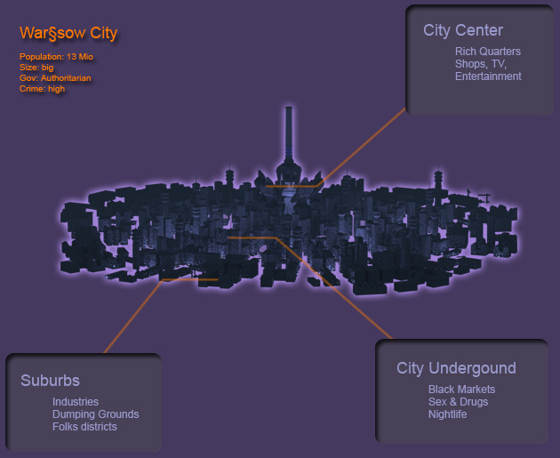
Suburbs
Not a wonderful place to live, but it's the only place you can find certain types of materials, which are high valuable in the black markets. Inhabitants are poor and rejected people, which conduct low level living. The native punkers tribes are the only rule, since the city police usually don't care about the area. On the border of the suburbs, there are metal mines and refineries, which are almost the only "legal" way to earn money if you come from the suburbs. These places are often victim of terrorist and sabotage action, and the government usually puts there some control forces, to maintain the facilities operational.
City Underground
The old core of the city, now underground due to urban vertical expansion. A place where it's always night! Bars, pleasure houses, black markets, everything you need to conduct an insane living enjoying it. You find any kind of drug, weapon, body implant and whatever you may looking for. The only thing you need to know is: don't trust anyone!
City Center
Where the rich are. Government, police, institutions. Clean, bright, almost a virtual reality. Everything is under control of the police and the government uses strong manner to keep the place peaceful.

The game takes place so called arena (or simply maps) which represent places all around the city. The current Warsow maps are not yet fully integrated into the city, and we are working on the textures sets and maps details to make them fit the design. Anyway for those of you who want to give them a try we list a rough classification:
- metal mines WDM3, WTEST7, refinery WTEST13
- uderground area WDM6
- city center WDM5, WTEST4, WDM2,

Game Characers

Punks
The punks come from the lower class of the society. They make hard living, being close to violence and poverty. They live in the suburbia; industries, dumping grounds, poor quarters of the cities. They have their tribes, their rules, their way of settle matters.
- Technology: low level, build on fortune objects, garbage, and stolen goodies.
- Appearance: Punk hair, body implants, rough armours. Bad and dirty looking.
- Origin: Suburbs

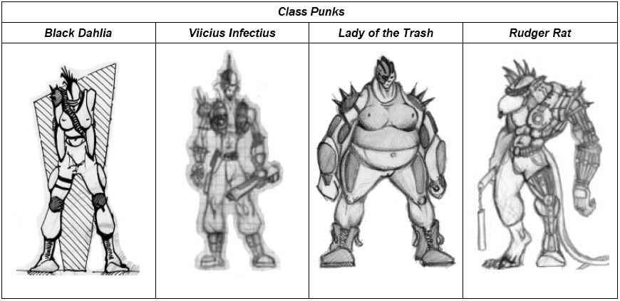

Monk Warriors
Monk warriors live in the city underground. They are dangerous people, psycho criminals, spy powered mind. Some of them are bounty hunters for the government, some are lone and free travellers, others are organized in bands and live in specific area of the underground. Their ranks counts many mutants, cyborgs, and other non-human beings. (Take, for those who knows, of the Dune's “bene gesserit” and “honoured mothers”, and influence then a bit with Asiatic and Buddhist philosophy).
- Technology: psyco-drugs, mind powers.
- Appearance: wearing robes plus armours, face is usually hidden.
- Origin: Underground

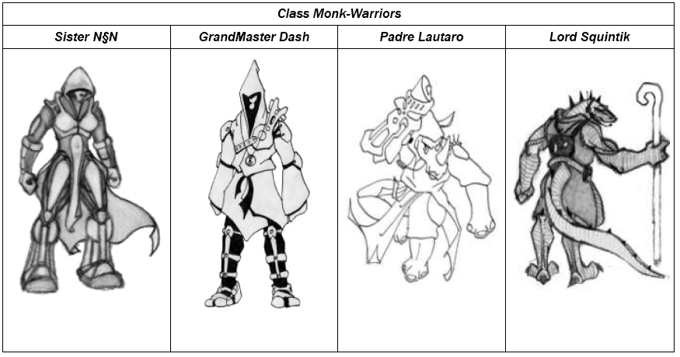

Space Marines
Space Marines are mercenaries for the government. They are high tech equipped solider, which do all the jobs ordinary police cannot handle. They are sometimes sent to the underground and government installations close to suburbs, to stop riots and unappreciated crowd manifestations. They don't feel regrets or fear, but aren't the smartest guys on the planet.

- Technology: high-level, sponsorized by the government.
- Appearance: combat body armours, big weapons, dumb expressions.
- Origin: Center

